## 

## 

## 

## 

## 

## 

Stoic Solutions

## 

## 

## 

## 

## 

## 

## 

Team (stoicsolutionscsusm@gmail.com):

Adam Hebel, Brian Rattanasith, Chris Bertram, Connor Myers,

Enrique Jimenez, Jerry Compton, Jordan Mower, Matthew Adamus

**Table of Contents**

**1. Application Development** **3**

1.1 Statement of Business Context 3

1.2 Statement of Customer’s Business Problem 3

1.3 Statement of Project Proposal 3

1.4 Statement of Deliverables 3

1.5 Measures of Success 4

1.6 System Overview 4

**2. Requirements Matrix** **6**

**3. Project Management** **7**

3.1 Product Breakdown Structure 7

3.2 Work Breakdown Structure 8

3.3 Initial Schedule for Tasks and Deliverables 9

3.4 Statement of Total Price 13

3.5 Gantt Chart 13

3.6 Initial Project Cost Tracking Chart 15

3.7 Statement of Deliverables 16

3.8 Outline of Resources Needed 16

**Team Information** **18**

**Appendix** **21**

To: Dr. Kristin Stewart, Assistant Professor of Marketing

CC: Dr. Shaun-inn Wu, Director of Projects

Stoic Solutions enjoyed being a part of this amazing project for Keep America Beautiful. Thank you Dr. Stewart for providing us with this opportunity to be a part of not only a fun and engaging project but also a great cause. We enjoyed every moment of this project, working with you through the semester, and making this project come to fruition. We also learned how to properly manage a project and work with a client to make a project successful.

The final phase involved the team finalizing all documentation and any last modifications to the database that were requested in the Prototype 2 meeting. All information and documentation of the work that was accomplished by Stoic Solutions will be available through the github link in the Statement of Deliverables. The team successfully created a functional database that communicates with the previous groups algorithm. The database is open for use by the UI team and everything has been created on the existing AWS server put in place by the previous group.

Regarding the accrued and projected cost of this project. Our team was operating at a rate of $28.00 per hour over the course of the project. Our estimated total cost was $17,030.40 but, the actual cost amounts to $16,108.60, this includes our hourly rate and the cost of running the AWS server.

A copy of this report will be submitted to both Dr. Stewart and Dr. Wu

By signing below you hereby approve Stoic Solutions to continue working on the following project: Keeping America Beautiful: Litter Detective, and agree to the aforementioned estimated costs.

Thank you,

Chris Bertram (Project Lead)

stoicsolutionscsusm@gmail.com



___________________________________________ ______________

*Dr. Kristin Stewart, Assistant Professor of Marketing Date*

# **1. Application Development**

## 1.1 Statement of Business Context

Keep America Beautiful is a national nonprofit organization that strives to improve, educate, and beautify both the environment and people. With more than 600-community based affiliates, partners, volunteers, and more, they are able to perform just so.

## 1.2 Statement of Customer’s Business Problem

* Keep America Beautiful needs the data produced by the algorithm to mean something.
* Needs the data produced to have a rating system.
* The definition of a geographical space must be defined to signify cities, counties etc.
* Make the data available and usable for the UI team.

## 1.3 Statement of Project Proposal

* Goal 1 - Collect data from 360 Google Street images.
* Goal 2 - Process images through ML.
* Goal 3.1 - Collect output data.
* Goal 3.2 - Define what a geographic space is.
* Goal 4 - Make data accessible to the UI team.

On behalf of Dr. Kristin Stewart we will implement the following with the intent of making this data usable and available to the UI team.

## 1.4 Statement of Deliverables

* Database filled with all data produced by the existing algorithm for UI team usage.
* Data will include:
  + Total litter in a given area.
  + Litter rating of 1 to 4.
  + Geographic space (Latitude, Longitude).
  + The date it was taken.

## 1.5 Measures of Success

**JAD 1 -** Identify requirements of the project.

**JAD 2 -** Finalize requirements of the project.

**Prototype 1 -** Boneworks of database created. Image collecting script fine tuned and

images collected and ready to be passed through the algorithm to collect

data.

**Prototype 2 -** More routes collected and a filled database of data from the San Marcos

area.

**Final Product** **-** Collation, transfer and storage of litter metrics from GSV360 images

that have been processed through a machine learning algorithm for use

by the UI team.

## 1.6 System Overview

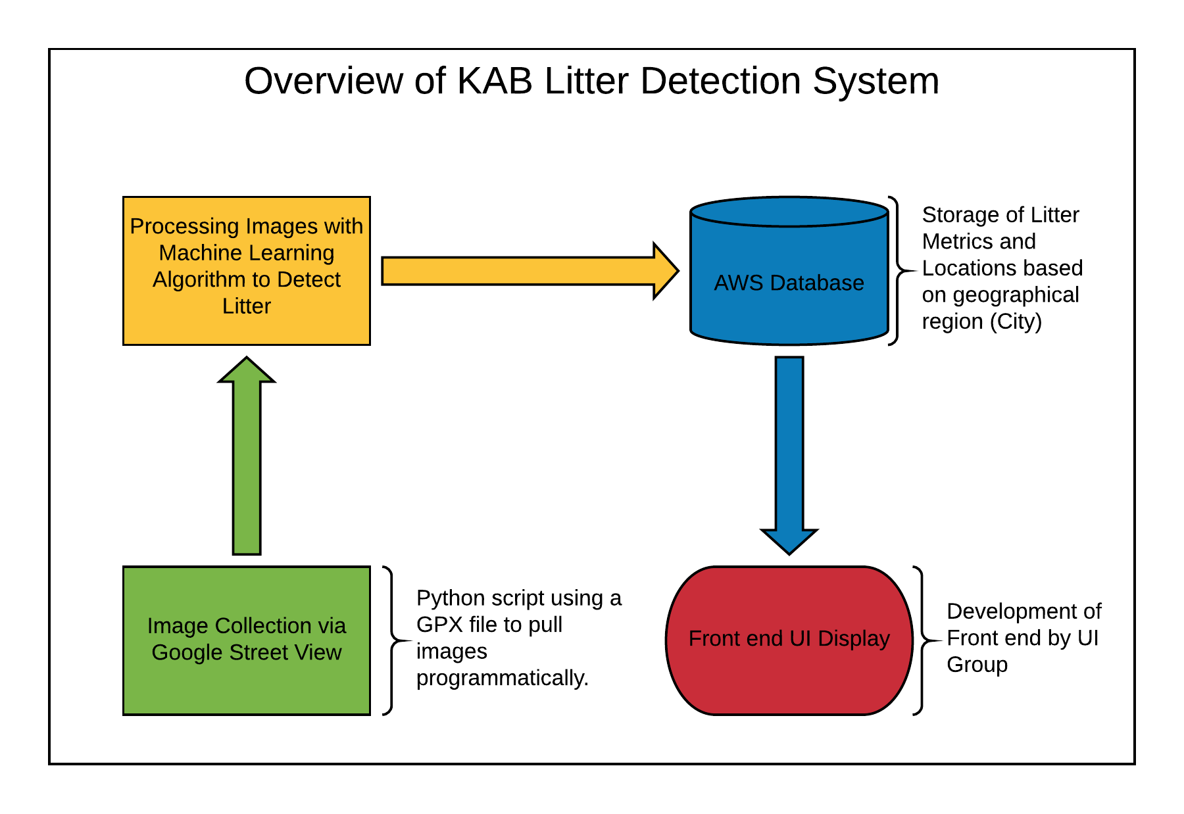

Table(s):

**SanMarcos** ( datapoint_id, latitude, longitude, kab_rank, litter_count, date_taken )

**ERD**

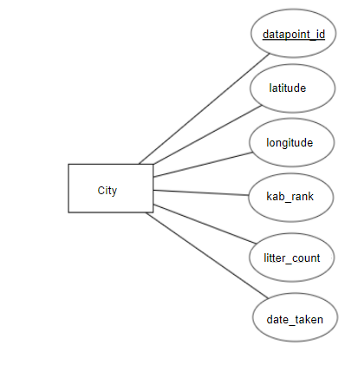

CREATE TABLE SanMarcos (

datapoint_id INT(11) AUTO_INCREMENT,

latitude double,

longitude double,

kab_rank FLOAT,

litter_count FLOAT,

date_taken DATE,

CONSTRAINT datapoint_id_pk PRIMARY KEY(datapoint_id));

# **2. Requirements Matrix**

|  |  |  |  |  |  |
| --- | --- | --- | --- | --- | --- |
| Req. ID | Requirement | Description | Critical | Implemented [Y/N] | Task ID |
| 1 | Image Collection | - Script will capture 360 View, Google Maps, Google Street images and Plotaroute. | H | Y | 5.6, 5.6.1 |
| 2 | Machine Learning Processing | - Algorithm will process 360 google images.  - Will indicate trash in images. | H | Y | 5.6.2 |
| 3 | Organize Data from Algorithm into final product | - Algorithm will transfer data to database.  - Will organize into specified fields: total litter, litter rating, latitude, longitude, and date taken. | H | Y | 7.7, 7.7.3, 8.5, 8.5.1 |

# **3. Project Management**

## 3.1 Product Breakdown Structure

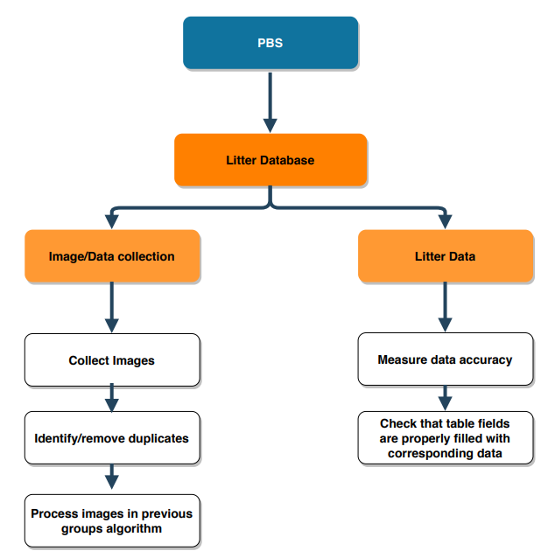

## 3.2 Work Breakdown Structure

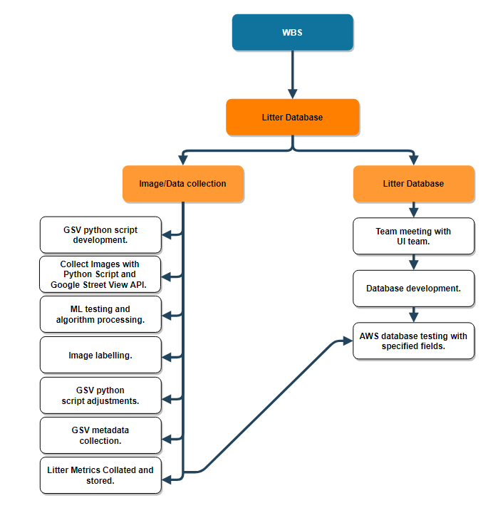

## 3.3 Initial Schedule for Tasks and Deliverables

**Schedule of Tasks:**

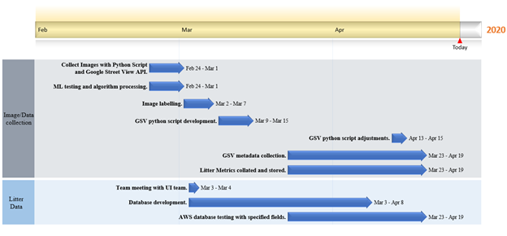

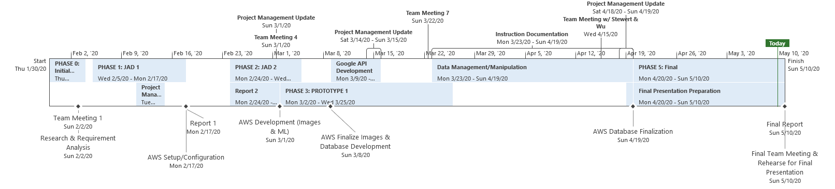

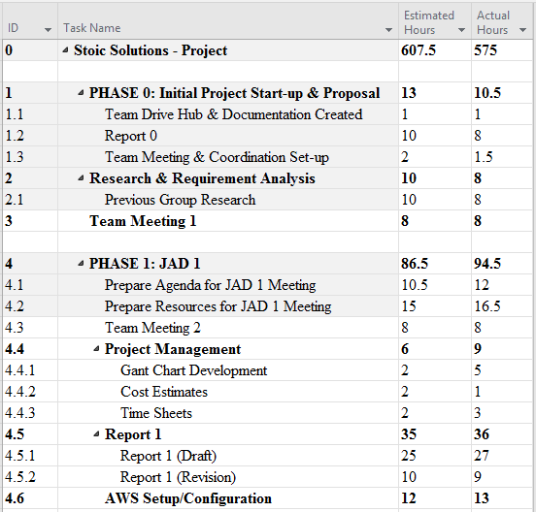

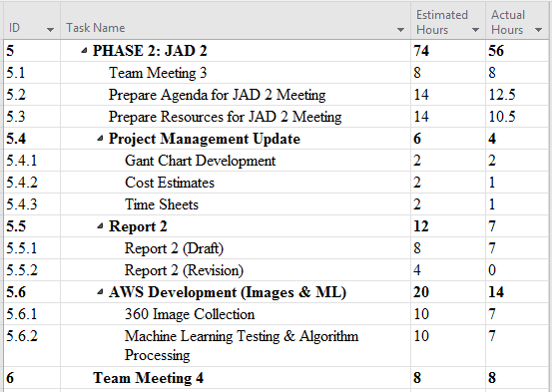

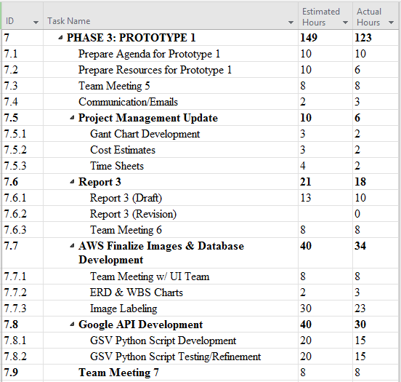

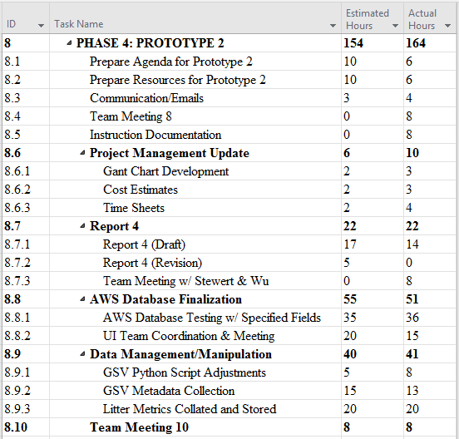

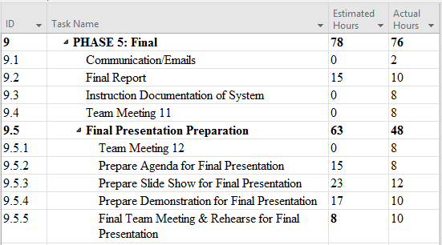

## 3.4 Statement of Total Price

As stated in our initial letter and agreement, the team will be operating at a rate of $28.00 per hour for each member of Stoic Solutions. The AWS server for the Machine Learning Algorithm will cost .29 cents per hour to run. The database server is a Free Tier AWS RDS t2.micro and comes with 750 hrs of free use. We can export the database so future groups can use the data if needed. Altogether, the total cost of the entire project calculated is $16,108.60‬.

## 3.5 Gantt Chart

Our gantt chart hours project actual hours for all Phases.

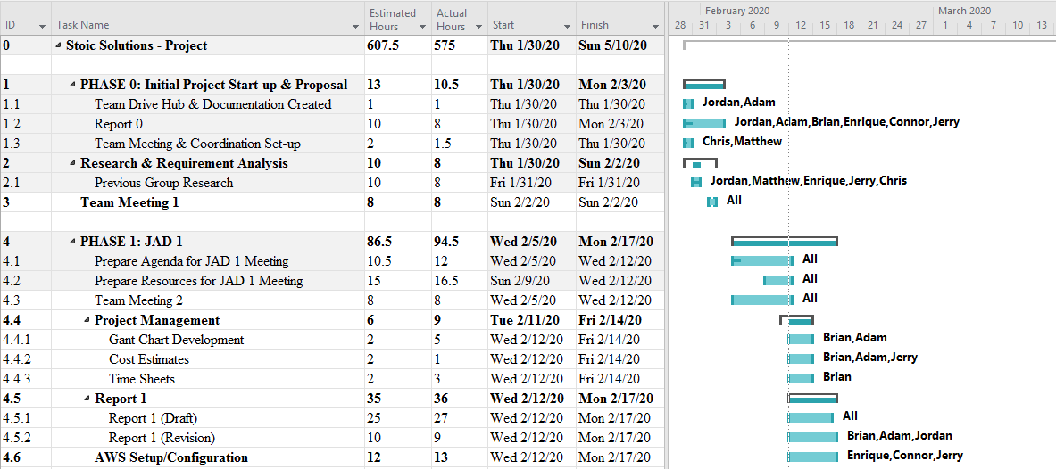

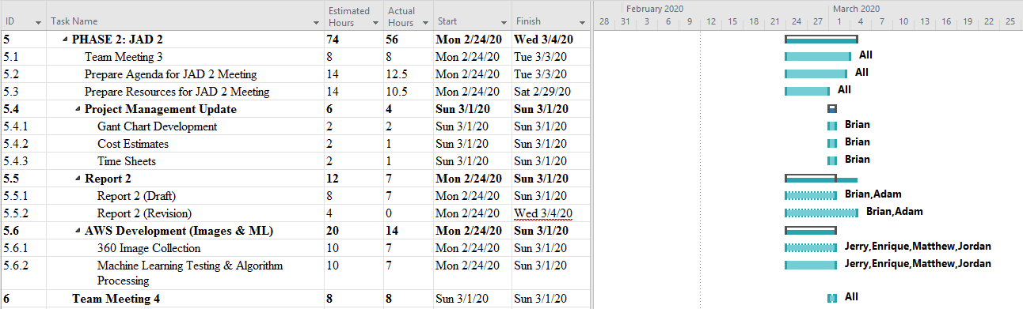

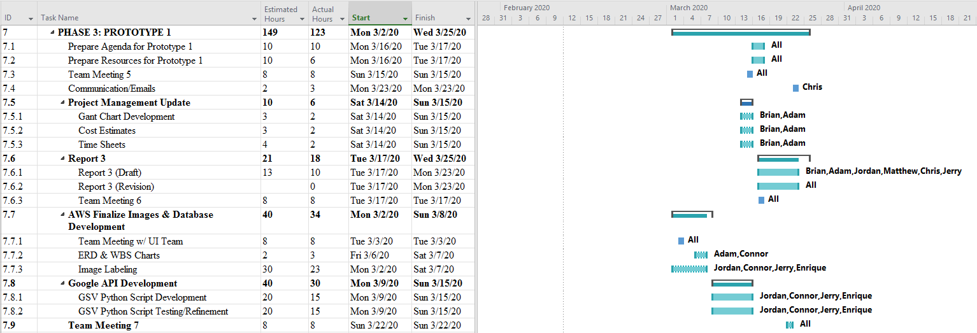

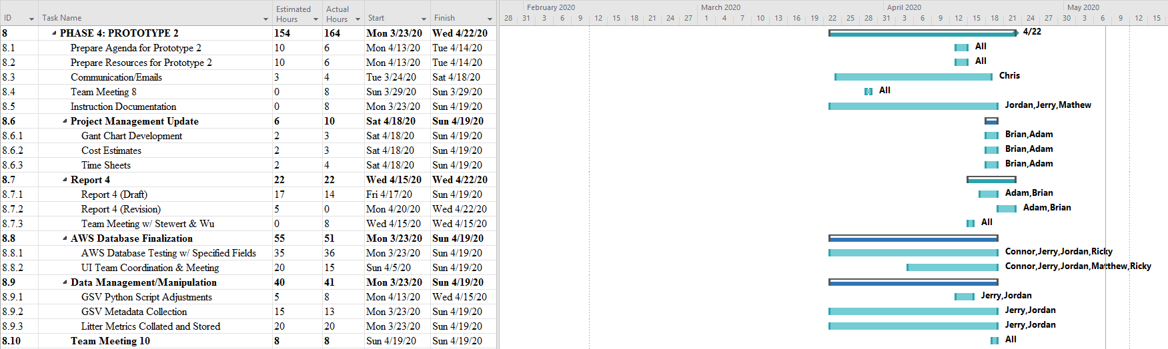

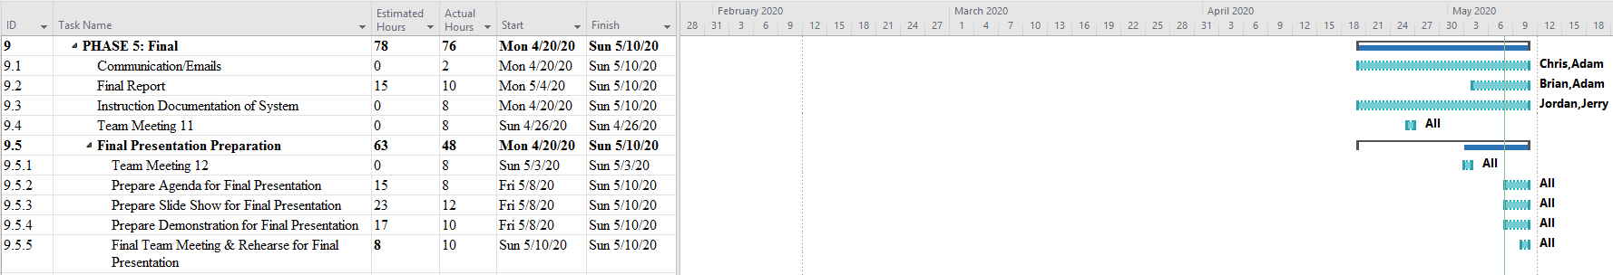

## 3.6 Initial Project Cost Tracking Chart

Below are the costs accumulated based on the team’s total hours worked. AWS was not configured entirely for Phase 0 & 1, but is represented and accrued at later phases. Phase 5 primarily consists of work on documentation.

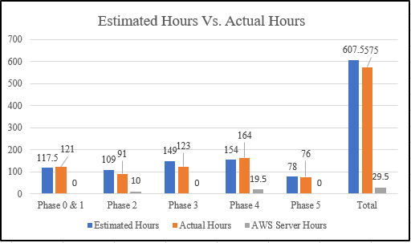

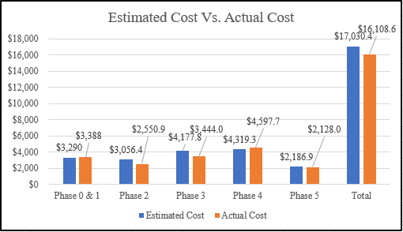

## 3.7 Statement of Deliverables

The Stoic Solutions team will deliver the following final products:

* Street2.1.py
  + Python script used for parsing GPX files, fetching images from Google Street View, and storing them locally on a machine.
* StoicSolutions_KABProcessor.ipynb
  + Python script used for processing images on the machine learning server and saving image data to a text file in the format: [Latitude],[Longitude],[KAB Rank],[Litter Count],[Date Processed].
* SanMarcosData.txt
  + Text file produced by StoicSolutions_KABProcesser.ipynb containing data for all processed images. This data is unrefined and is not representative of what will appear in the database. Mainly, there will exist duplicate latitude/longitude pairs because each coordinate produces two angles.
* Database Implementation & Details
  + Database ERD (Entity Relationship Diagram)
  + Database credentials and access parameters.
* Documentation
  + All above information is located on the GitHub link located below.
  + GitHub link: https://github.com/stoicSolutions/cis490_2020_project

## 3.8 Outline of Resources Needed

The following resources are what the Stoic Solutions team will be supplying:

* Extensive Knowledge of AWS and database implementation.
* Updated documentation.
* Research and testing.
* Database credentials and access.

The following resources are what the Stoic Solutions team will need supplied from Dr. Stewart:

* Source code from previous team (Machine learning system).
* AWS Server Instance and Funding.
* Possible extra student labor to gather images since we will be doing a 360 view requiring 4 images rather than 1.
* Signage and approval for the Stoic Solutions team to continue working on the project.
* Availability for future meetings.

**4. Further Enhancements**

A future enhancement that should be implemented by a future team would be to automate route collection. This will make defining geographic areas much more smoother and would take away the tedious work required by the users since they won't have to manually create them.

Another improvement that could improve the project as a whole would be to speed up the ML algorithm’s processing speed. This will not only save time for future users who work on the project but, in order to make this algorithm into a full fledged app that will eventually be used by the world, it will need to be much faster.

The algorithm as it stands now gets the job done but, other than the improvements mentioned above there was one other that was tossed around during development that was out of scope for our portion of the project. This includes modifying the algorithm so that it can pinpoint specific objects in the images rather than just identifying it as trash.

Overall, over the course of the semester Stoic Solutions was able to finish all work within its scope and created a functional database that can be up-dated by the ML algorithm created by the previous team.

# **Team Information**

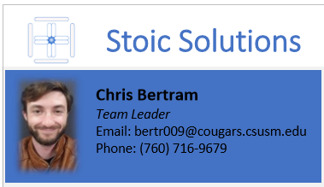

My role on the Stoic Solutions team is Team Leader. My primary role is to facilitate communication between different members of the team and the client(s) to ensure no losses in productivity and maintain continuity and consistency in the product, communication based or otherwise. This includes scheduling meeting times and providing documentation for various communications and workflows.



My primary role on Stoic Solutions is Project Manager. This includes organizing and managing tasks that will take place during the project and making sure that all members have something to work on and contribute to the project. In addition I will be helping with documentation and making sure every submission and task for the project is completed by the specified date as well as assisting where any other help is needed.



My role within Stoic Solutions is to help administer our new system onto AWS such that it can successfully deliver data to the KAB UI team. Another key responsibility will be ensuring that our data is of the desired format for the UI team. My background is in web development so I believe that I am well suited for these roles. Along with that, I will be communicating effectively with my team members to ensure that we are on track for all phases of the project.



My primary role in Stoic Solutions is documentation and training, but not limited to anything the team needs help with (Coding, configuring, etc...). My strength/focus is to understand, organize, and present the information given, so that everyone and everything correlates in a timely manner.



My tasks include problem anticipation, system utilization, refinement of abstract ideas, and documentation of the project as we progress. When applicable I will turn useful data or ideas still in the process of being defined, into visual representations. I will float to tasks as assigned by the Project Manager.



My role within Stoic Solutions is to work with our AWS Database and make sure that the UI team can use our data. My strength and focus is understanding data that is created and making it understandable for anyone to use.

My role within the Stoic Solutions team is to review and understand all documentation from the previous team and use my software development experience to add any necessary alterations and improvements so that our project goals are met.

My role in Stoic Solutions will be focused on documentation and training. However, since I have previous experience using Amazon Web Services and Python I will be helping the team with those aspects as well. I am suited for this role because of my attention to detail and organizational skills. Both of which are required for producing documents that future customers and programmers will find useful. 

# 

# **Appendix**

**Stoic Solutions Timesheets**

**Week 2:**

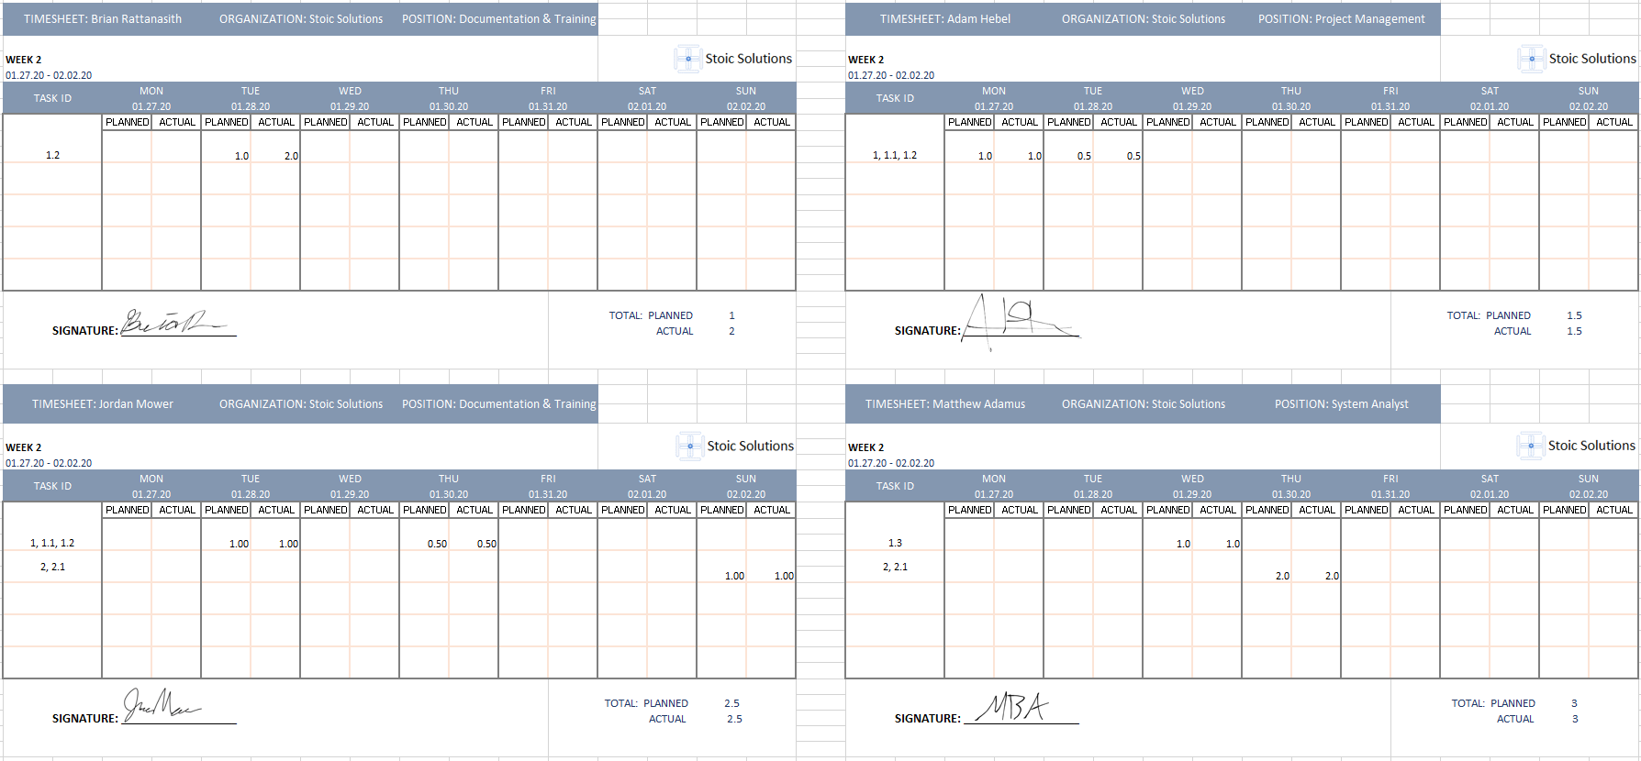

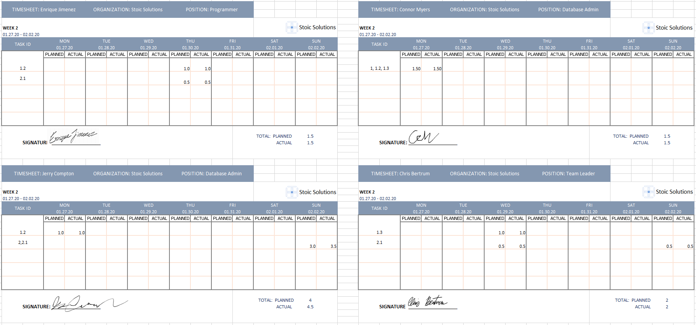

**Week 3:**

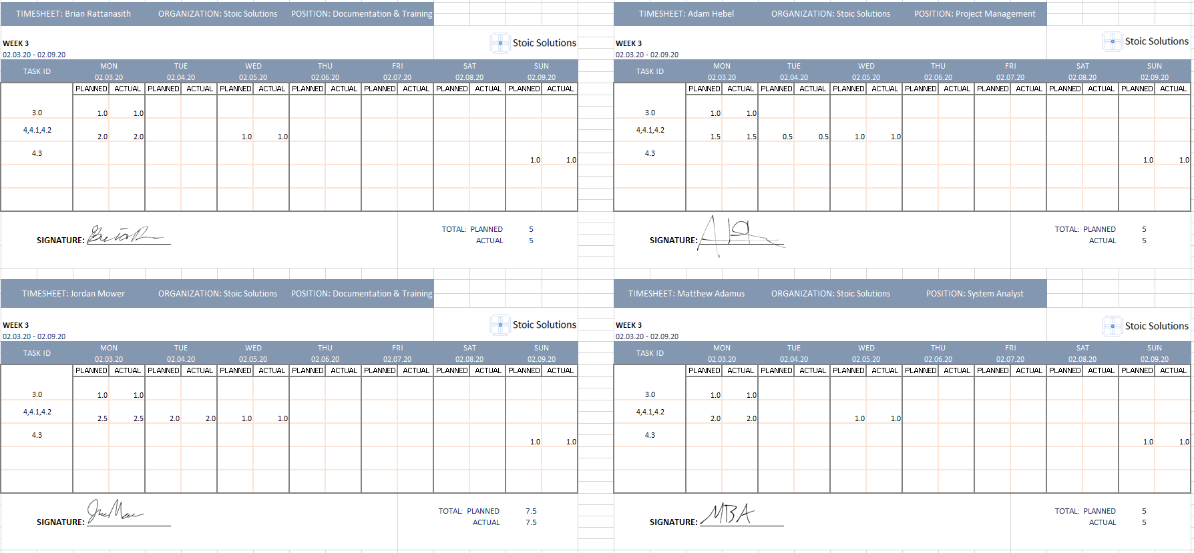

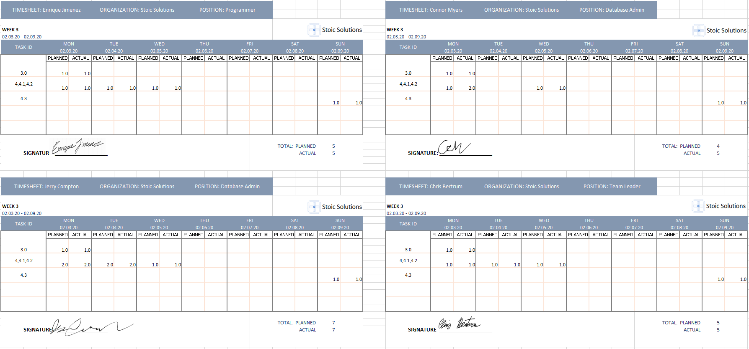

**Week 4:**

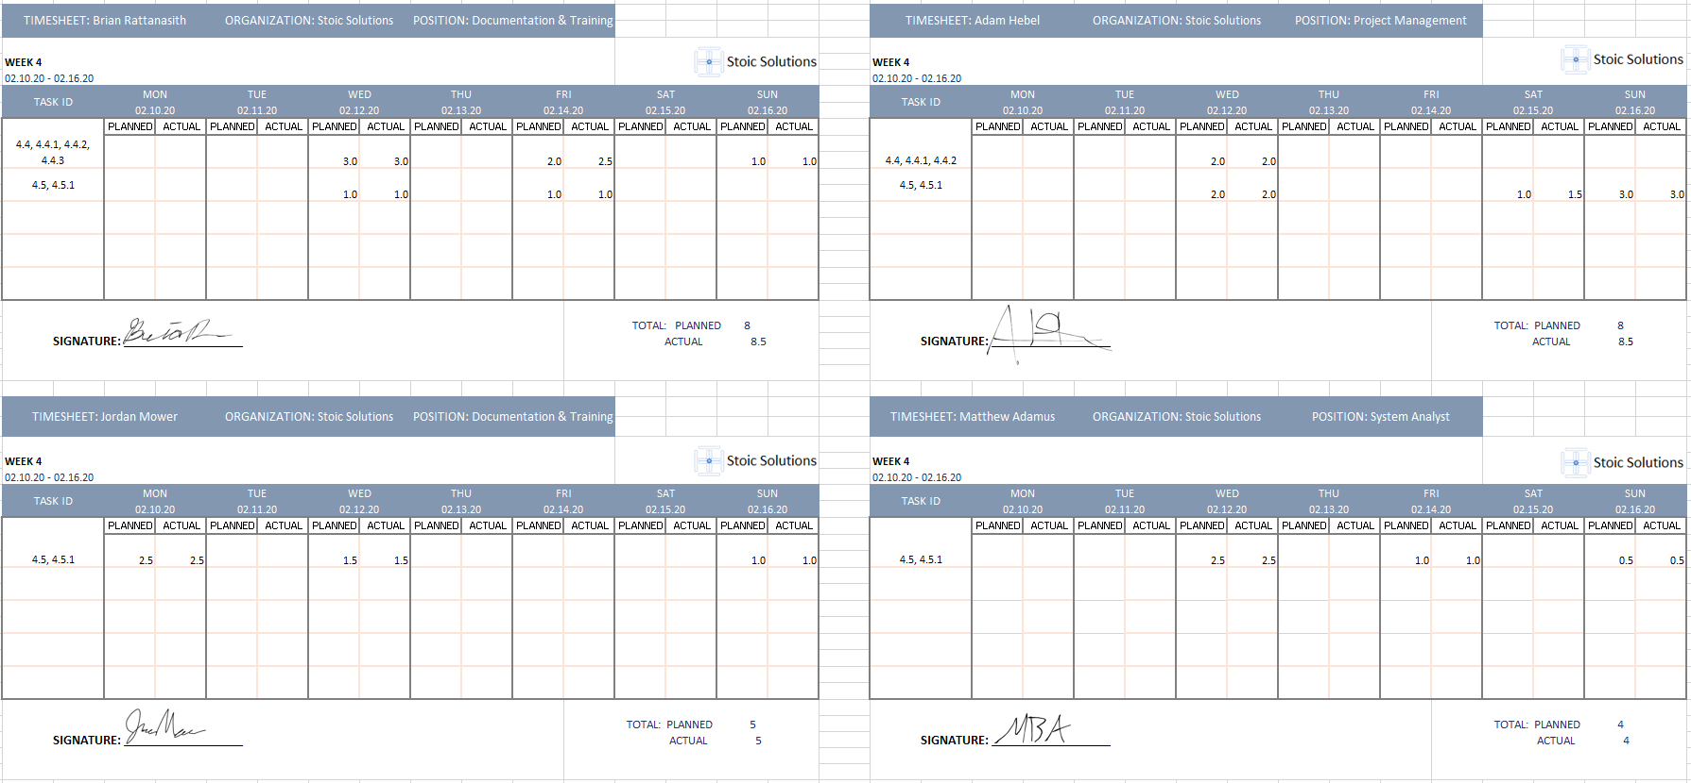

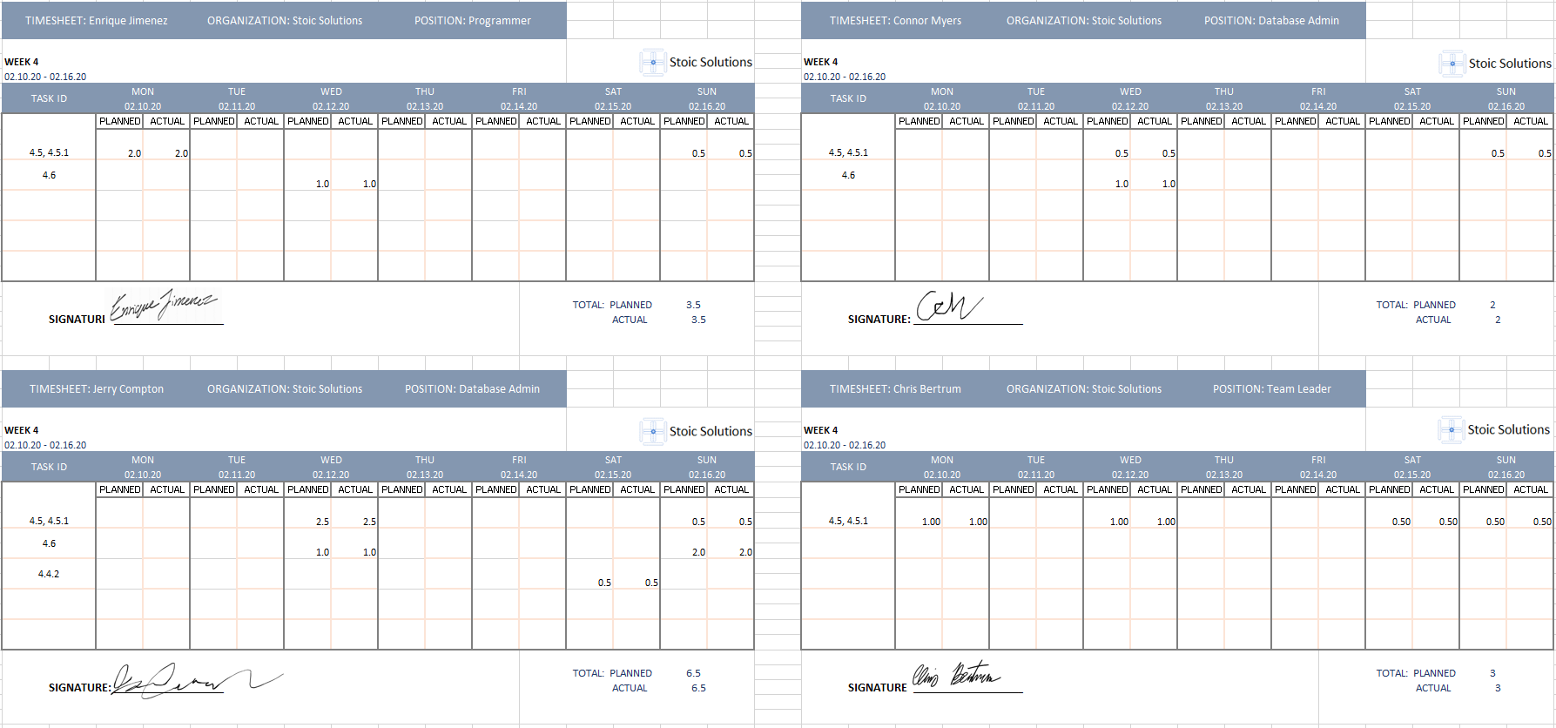

**Week 5:**

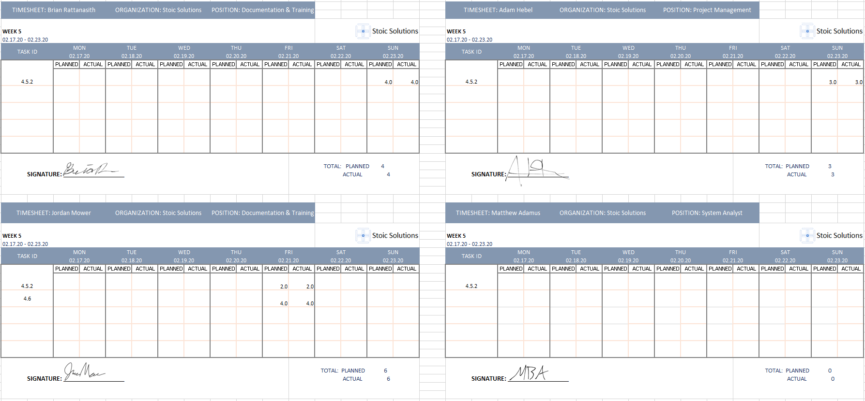

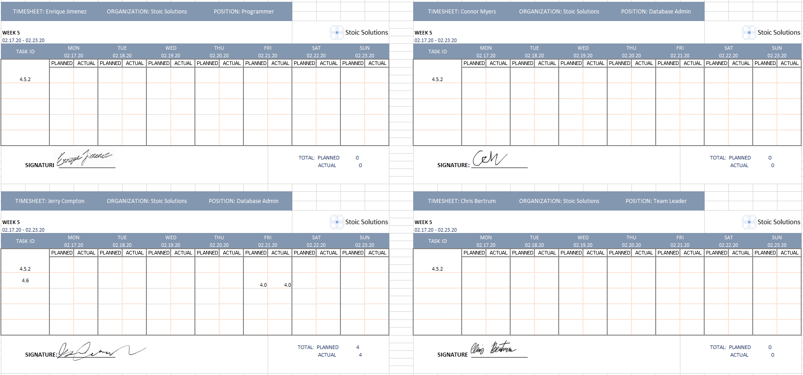

**Week 6:**

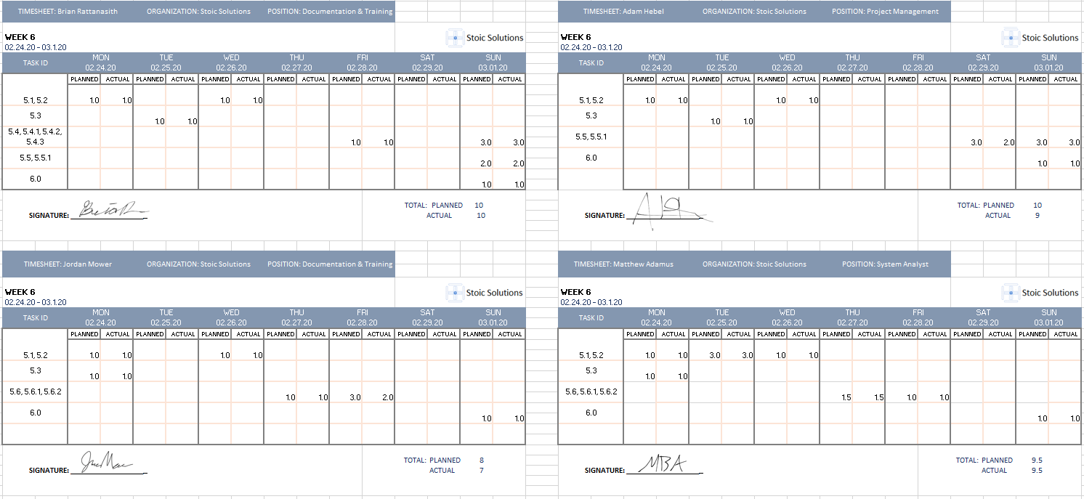

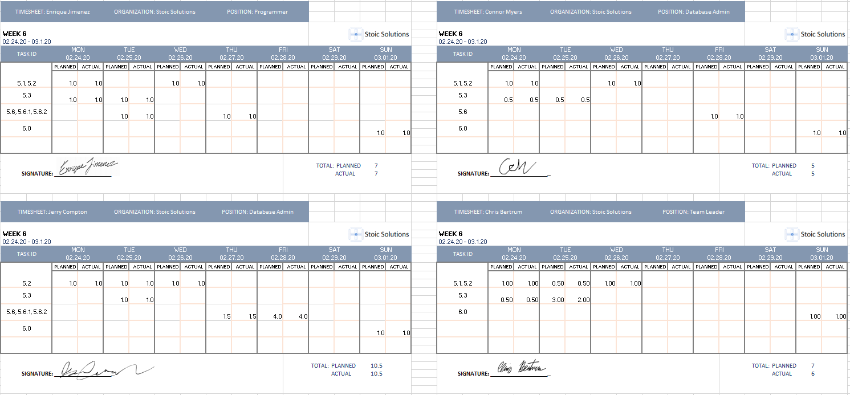

**Week 7:**

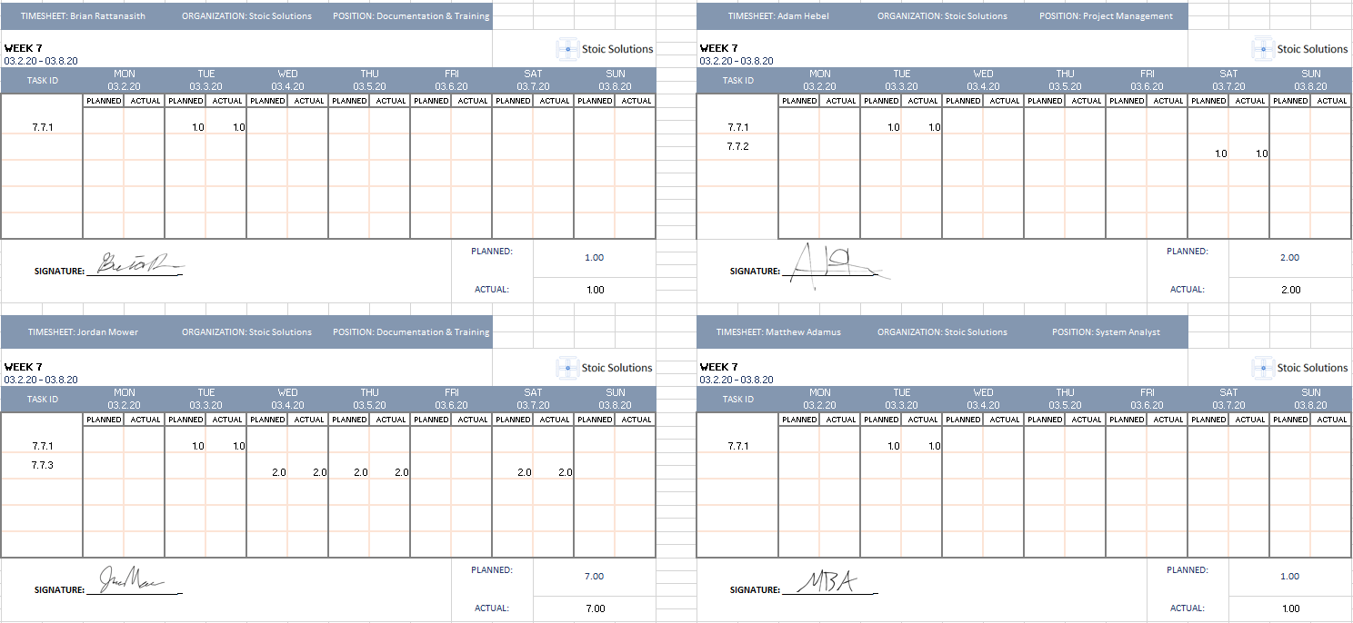

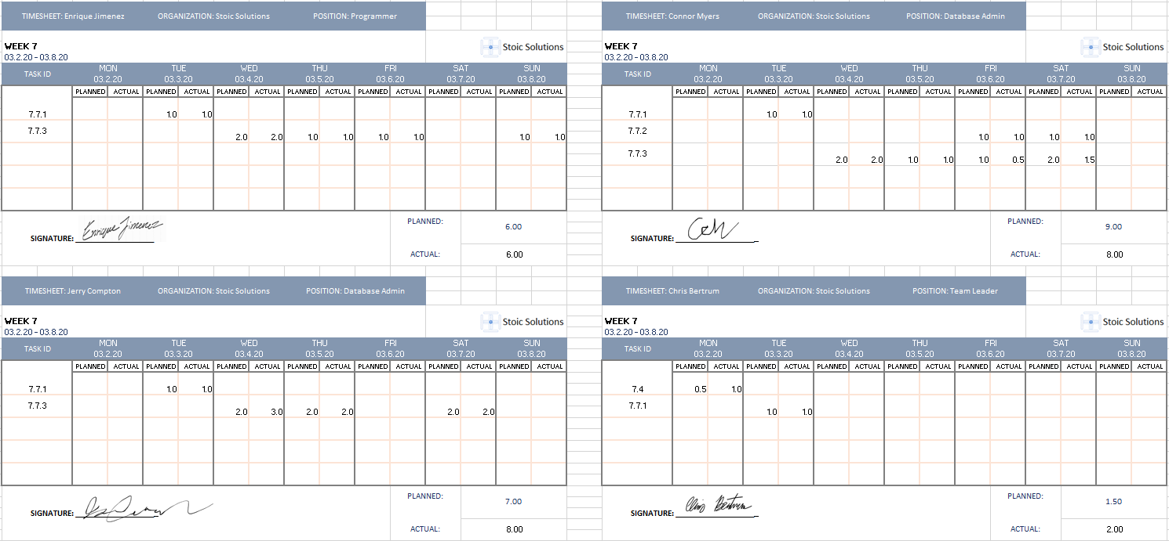

**Week 8:**

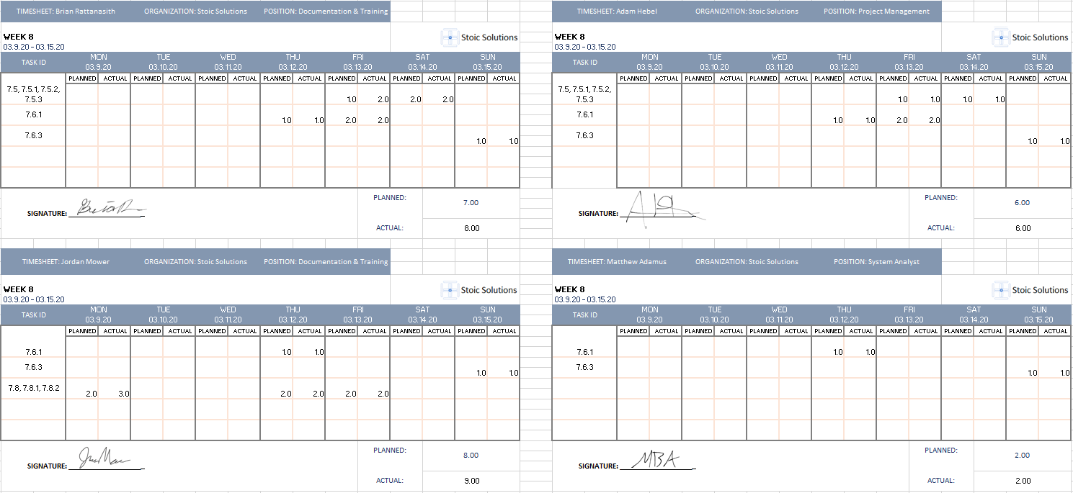

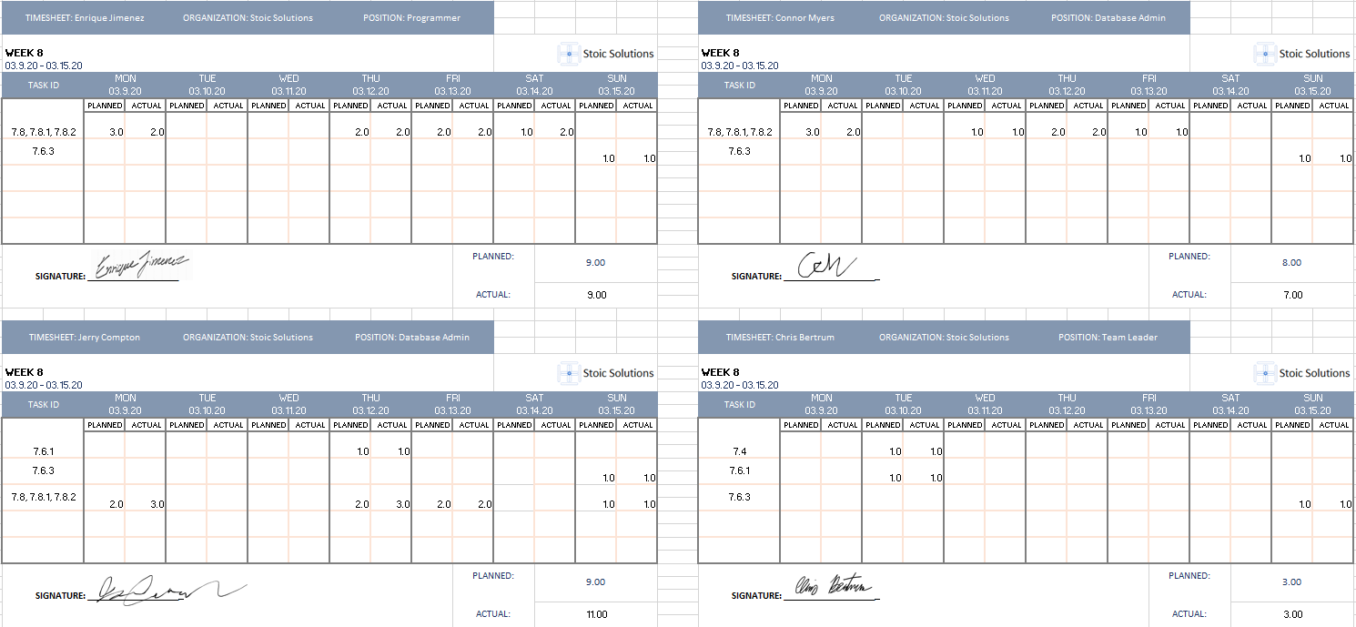

**Week 9:**

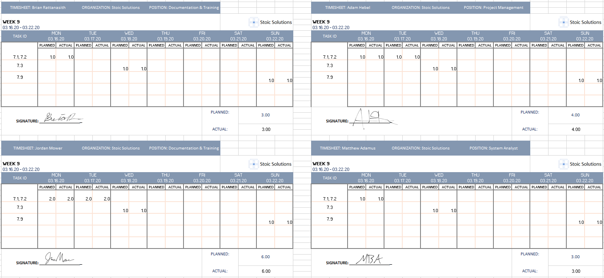

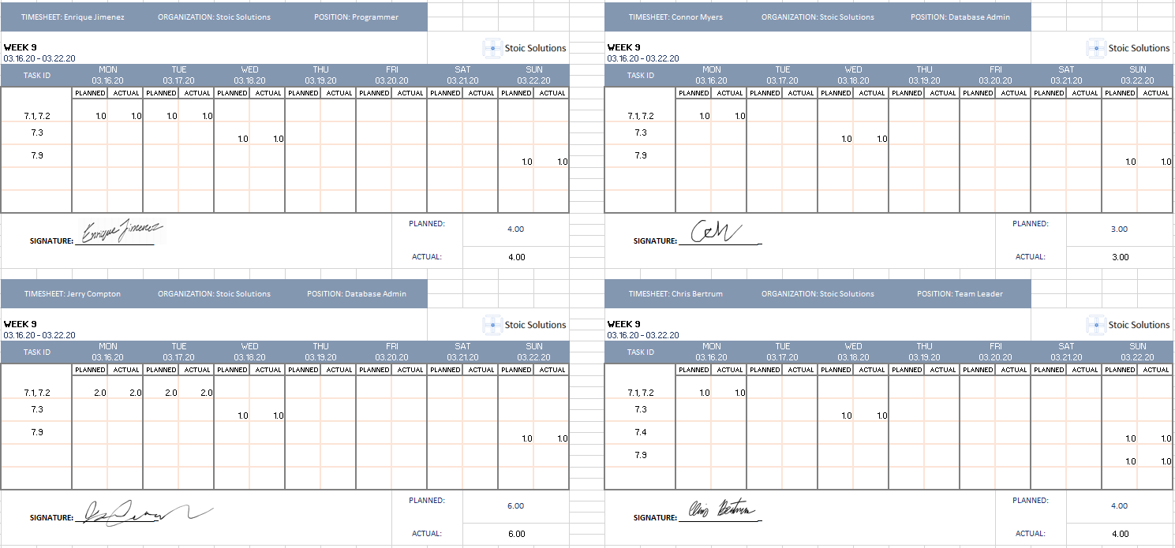

**Week 10:**

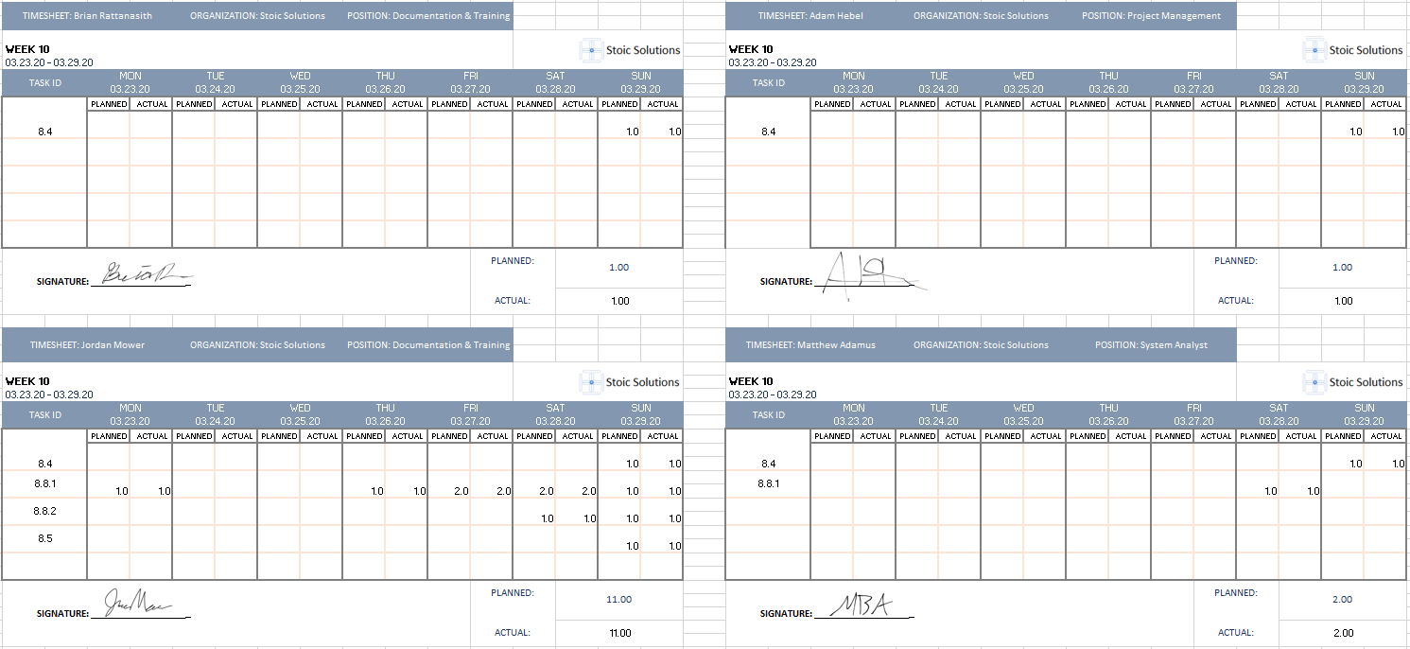

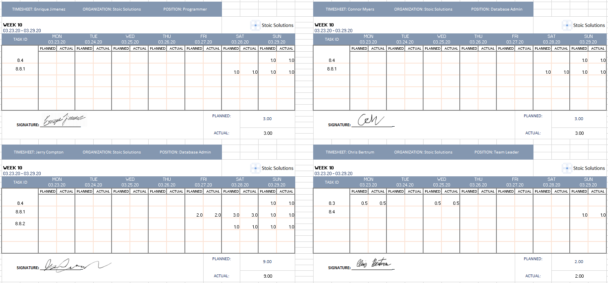

**Week 11:**

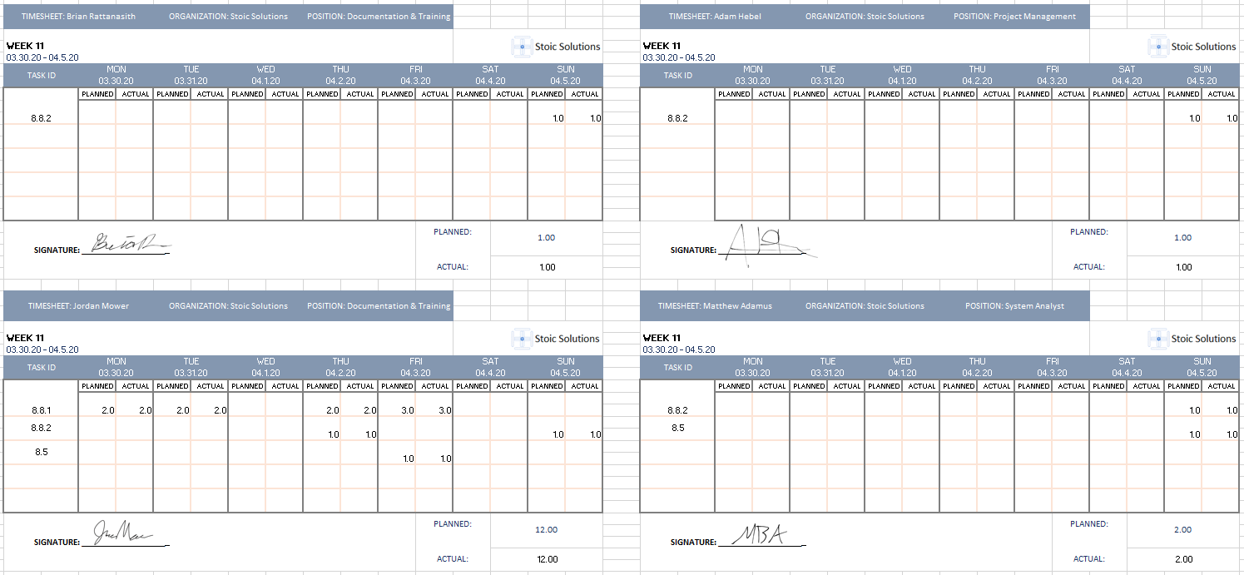

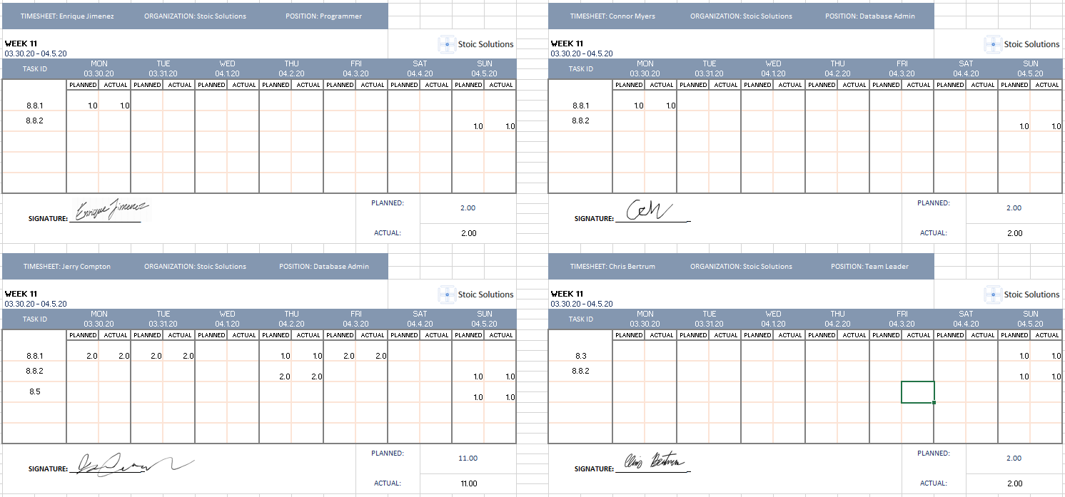

**Week 12:**

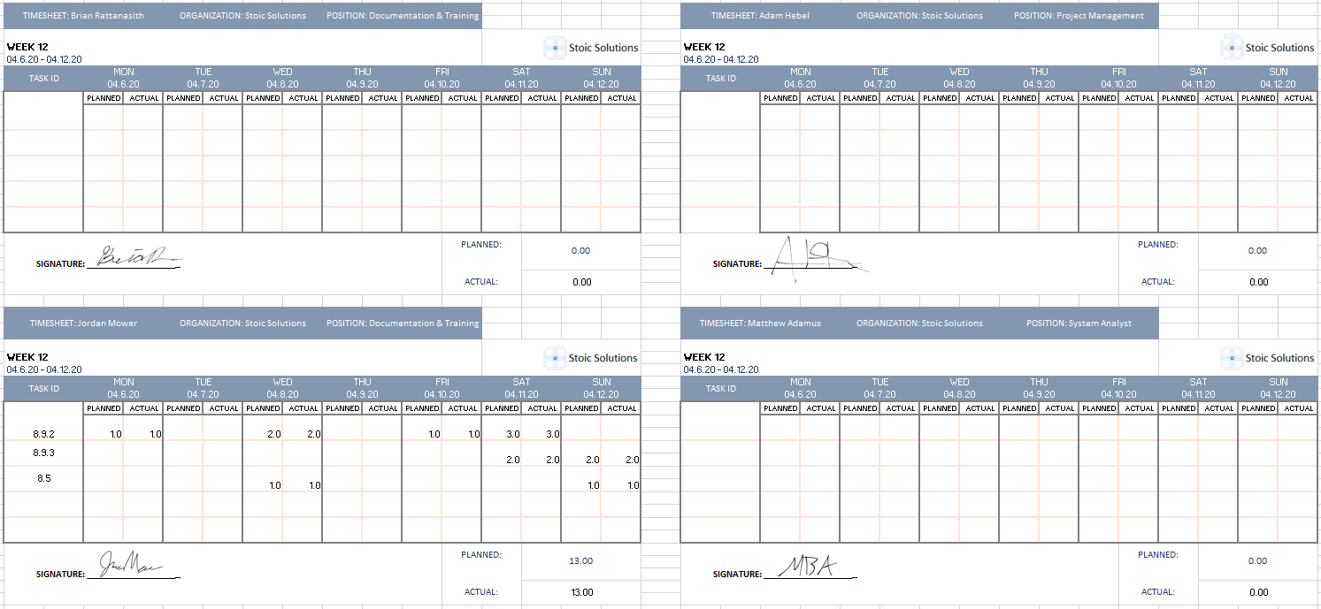

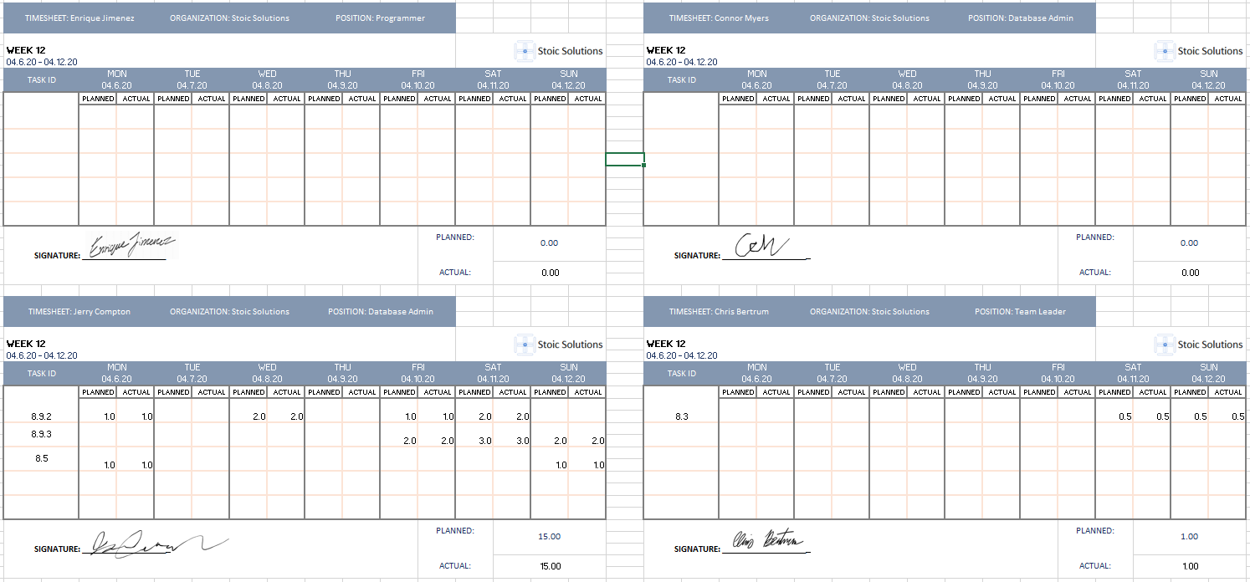

**Week 13:**

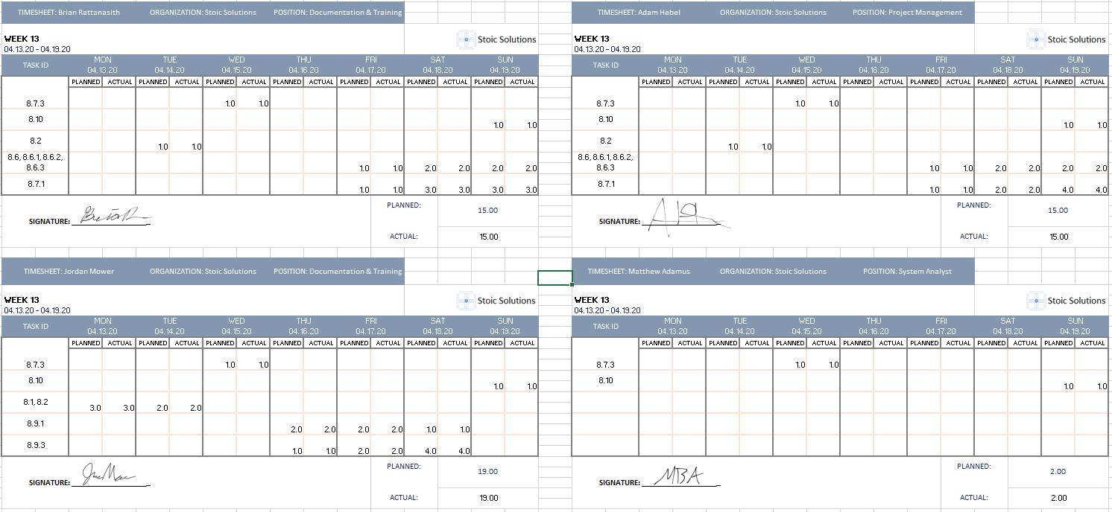

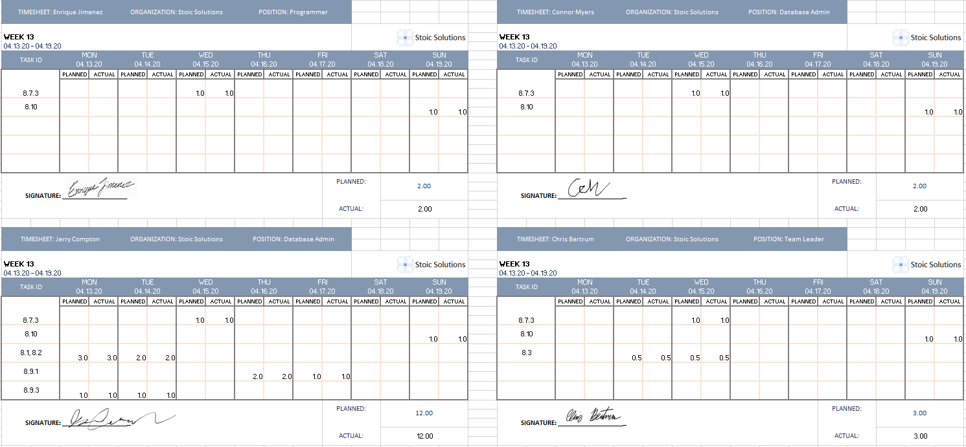

**Week 14:**

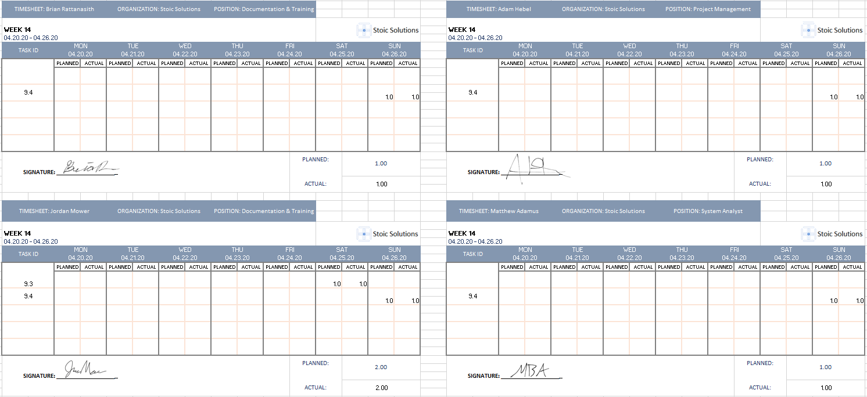

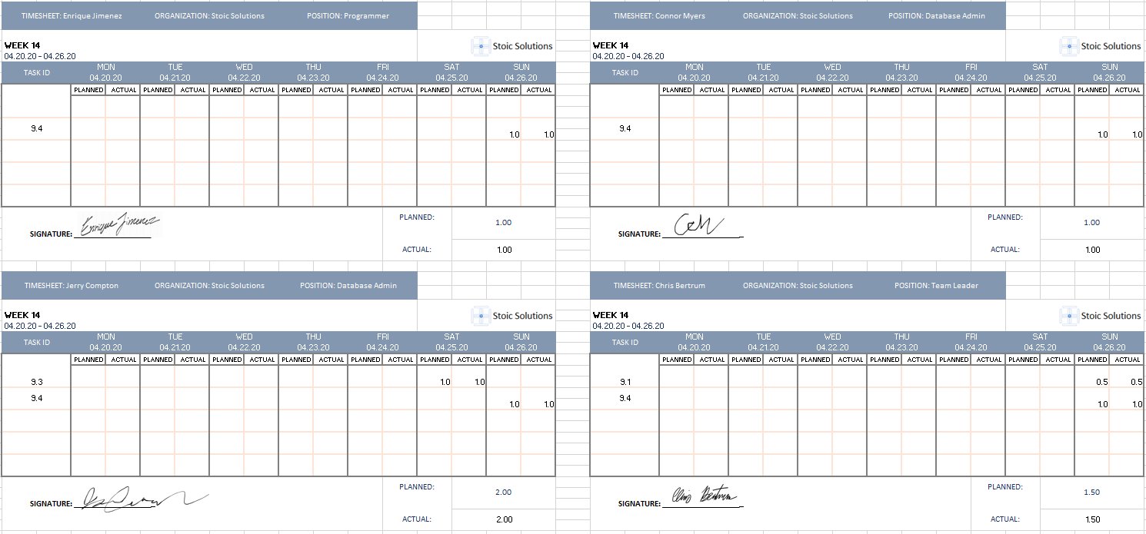

**Week 15:**

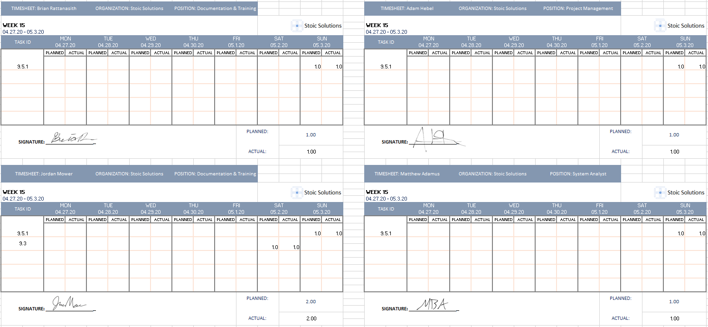

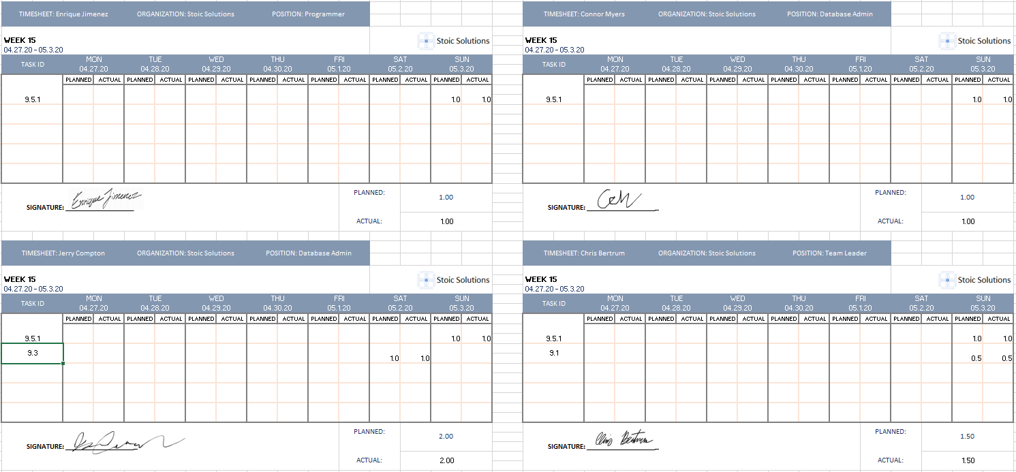

**Week 16:**

